Supervised Learning Regression Problem

Introduction

Title: Exploring Machine Learning Models

Purpose of the Analysis:

The aim of this analysis is to explore the performance of various machine learning models in predicting the 'Class' variable based on the provided dataset.
Understand how different algorithms handle the given features and contribute to the Supervised Learning Regression task.

Datasets Used:

The dataset used for electricity company and the percentage of increase and decrease in electricity
- AT (Ambient Temperature): The temperature of the surrounding air.
- V (Exhaust Vacuum): The exhaust vacuum pressure.
- AP (Ambient Pressure): The atmospheric pressure in the surroundings.
- RH (Relative Humidity): The relative humidity of the air.
- PE (Net Energy Output): The net energy output of the power plant.

Data Exploration and Data Preprocessing

Title: Understanding the Dataset and Preparing the Data

Summary Statistics:

Provide key descriptive statistics for numerical features.
Highlight any notable patterns or outliers.

EX:

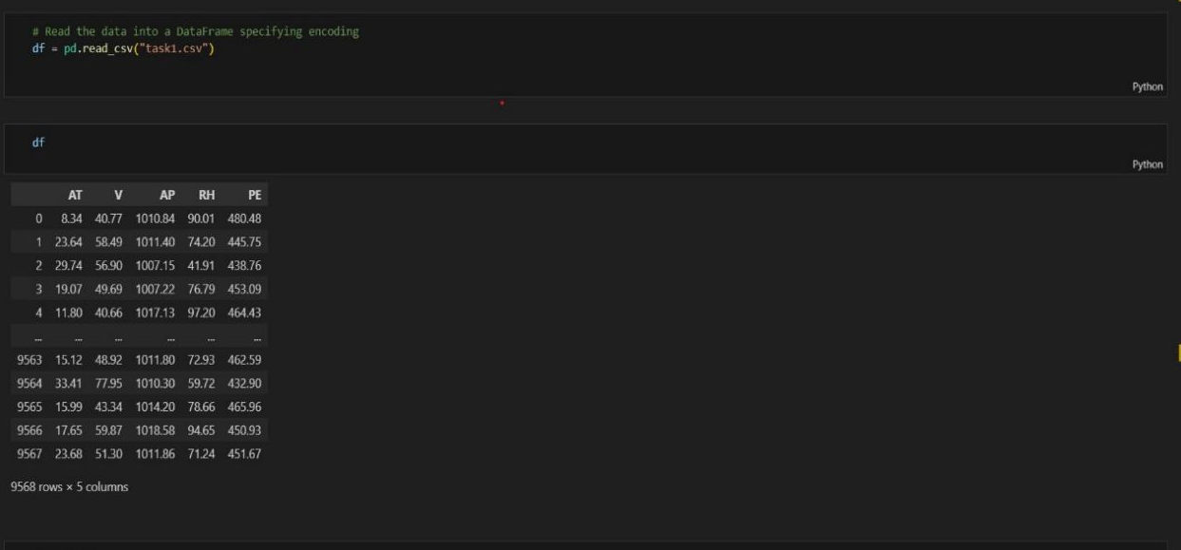
->He presented the introduction to the data set
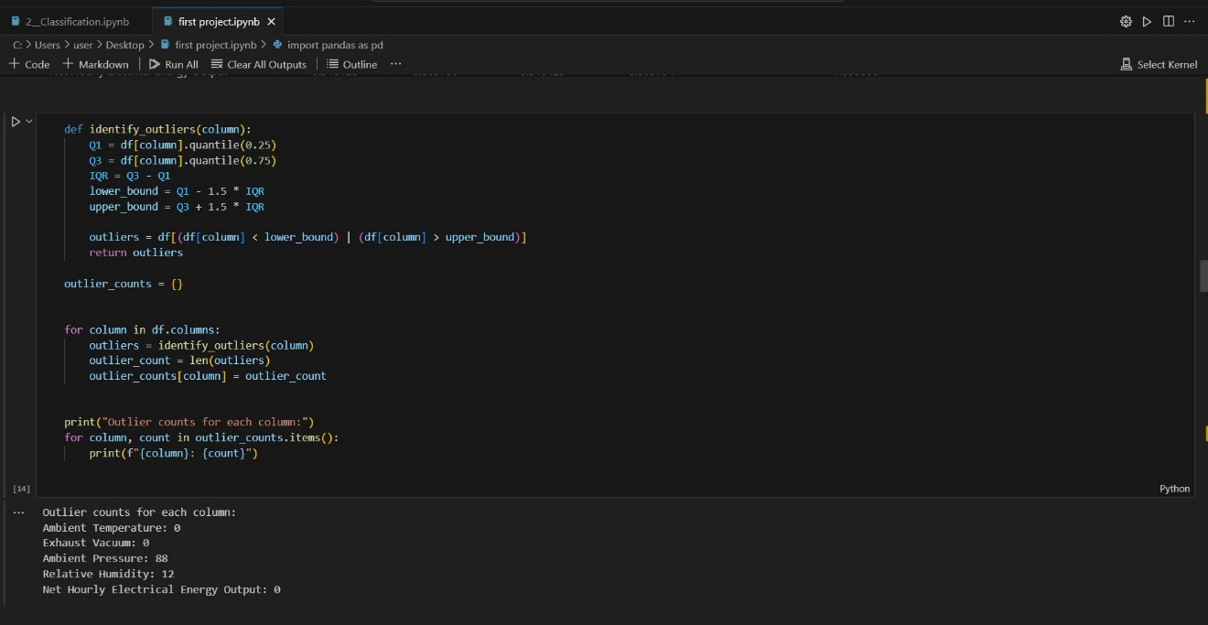
->Data after remove duplicates and Handling Missing Values.

Data Visualization:

Include visualizations like count plots for categorical variables.
Histograms and correlation matrices for numerical features.
Any insights gained from visual exploration.

EX:

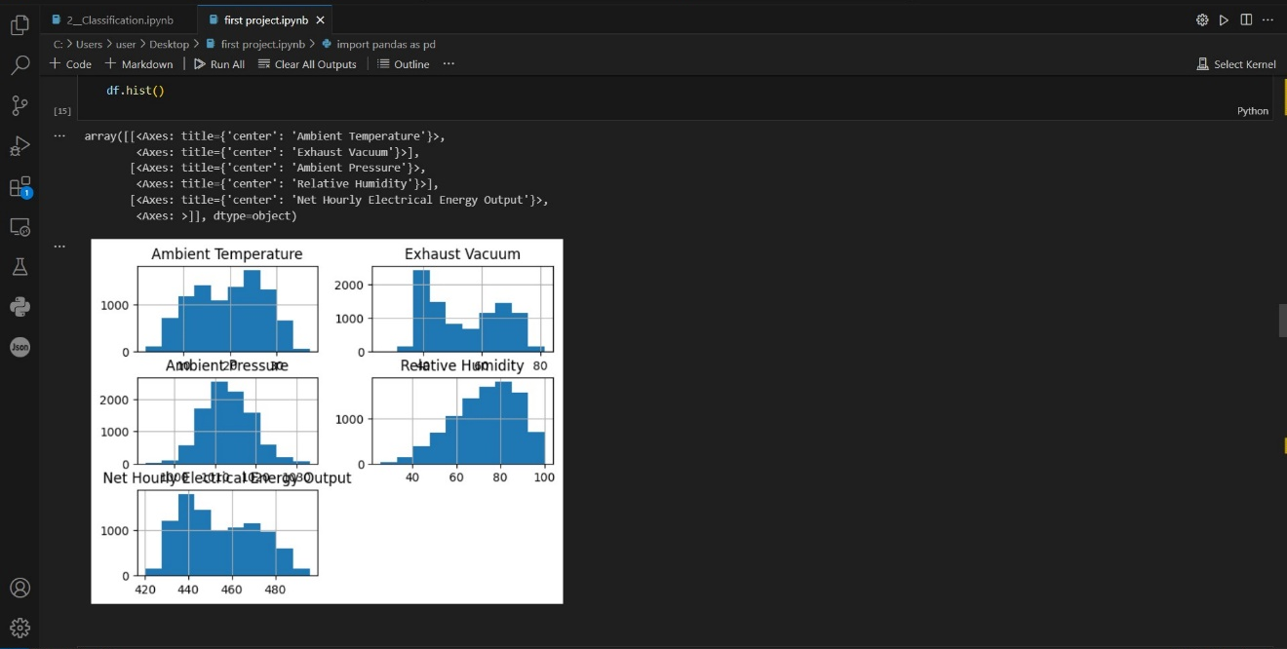
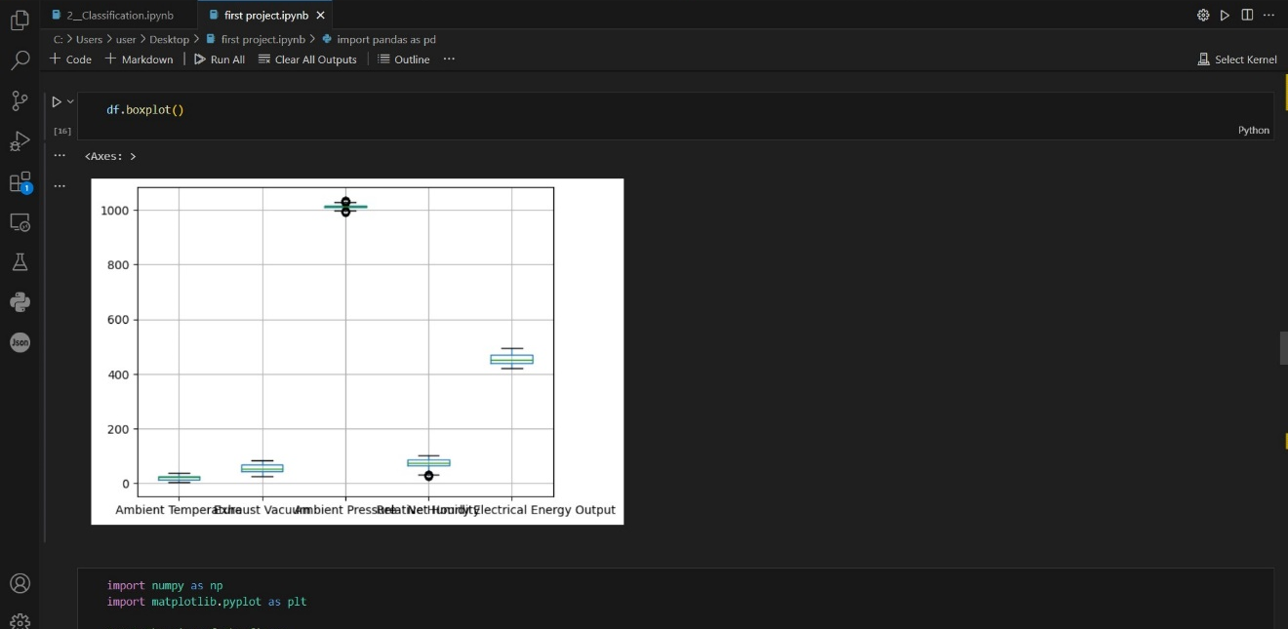
z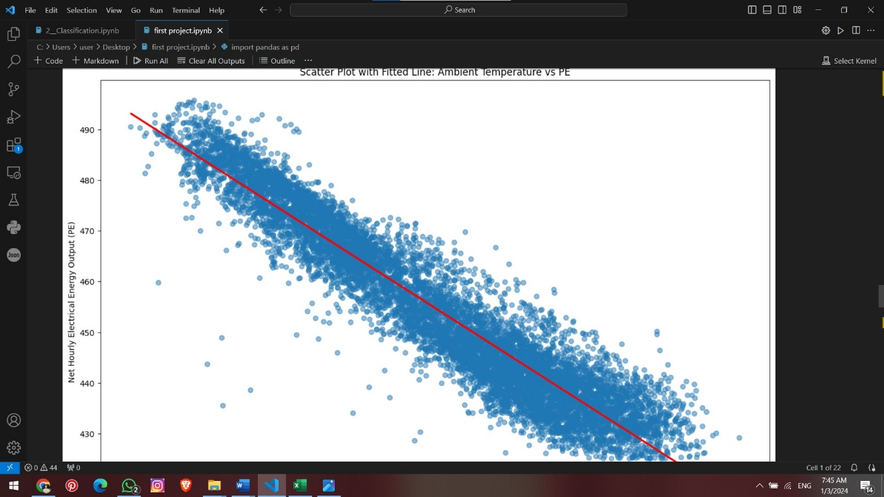

Machine Learning Models

- The dataset is split into features (X) and the target variable (y). Features are obtained by dropping the 'Class' columnfrom the original DataFrame (df), and the target variable 'Class' is assigned to y.

- The train_test_split function from scikit-learn is used to split the dataset into training and testing sets. The features (X) and target variable (y) are split into training and testing sets, with 80% of the data used for training (X_train and y_train) and 20% used for testing (X_test and y_test). The random_state parameter is set to 42 for reproducibility.

- Confusion Matrix:

- The confusion matrix is computed using the confusion_matrix function. It shows the count of true positive, true negative, false positive, and false
negative predictions.

- Feature Importance:

- The coefficients of the logistic regression model are extracted (model.coef_). These coefficients represent the importance of each feature in making predictions.
- A DataFrame (feature_importance) is created to store the feature names and their corresponding coefficients. It is then sorted in descending order of coefficients.
- A bar plot is generated using seaborn (sns.barplot) to visualize the feature importance.

Random forest()
Mean square error: 10.139
Root mean squared error:3.1842
R-Squared error:0.964
Pipeline Mean square error: 10.16180
Pipeline Root mean squared error:3.1877
Pipeline R-Squared error:0.964

Gradient boosting()
Mean square error: 11.16

SVC()
Mean squared error:19.682

Linear regression()
Mean squared error: 19.60

Lasso()
Mean squared error: 19.60

Ridge ()
Mean squared error:19.70

